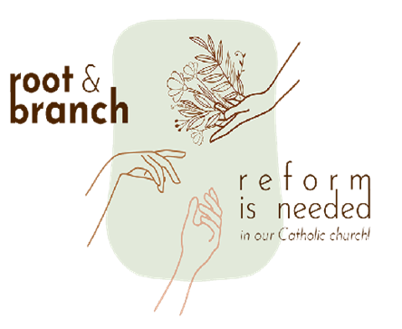

## Synod 2024 related article

## **From Catholic News New Zealand**

## Bishop Anthony Randazzo’s address, delivered as President of the Federation of Catholic Bishops conferences of Oceania to the synod media on October 6th, 2024, brought to light several crucial concerns:

## [Randazzohttps://cathnews.co.nz/2024/10/17/bishop-anthony-randazzos-address-to-the-synod-sheds-light/](https://cathnews.co.nz/2024/10/17/bishop-anthony-randazzos-address-to-the-synod-sheds-light/)

Ordinations during the Synod news

ARCWP (Association of Roman Catholic Women Priests) ordinations on the Tiber 17.10.24 pictures from Bishop Bridget Mary Meehan: <https://www.facebook.com/bridget.meehan/>

**Global reform organisations**

[WATAC](https://watac.net.au/) (Women and the Australian church): ‘modelling new ways of being church, based on a discipleship of equals’} has set up an Australian Women Preach podcast in which a woman preaches every Sunday online. Attracts many younger women: <https://watac.net.au>

**Be The Change Catholic Church Aotearoa**: ‘For a new, inclusive model of church’: alternative Zoom liturgies: <https://bethechangecatholicchurchaotearoa> “Feel free to join our liturgies!”

**Concerned Lay Catholics,** an “independent group of concerned committed lay Catholics formed in Canada to affirm the laity’s role of co-responsibility in the church”. Planning we are planning a Canadian Synod for June 2025 all will be welcome

**Tui Motu: a New Zealand independent Catholic magazine:** https://tuimotu.org/

**Prayer resources**

[**The Ordinary Office**](https://www.anordinaryoffice.co.uk/), UK. Online prayers and an online community space for everyone, especially people with disabilities. <https://www.anordinaryoffice.co.uk/>